

SAVEETHA SCHOOL OF ENGINEERING, SIMATS

Department of Computer Science and Engineering

Assignment Information

Particular | Details
Name: | Ankala Lakshmi
Register Number: | 192373066
Department: | Data science
Programme: | B.E
Course Code & Course Name | CSA1522 – Cloud Computing and Big Data Analytics
Academic Year / Batch | 2026–27
Faculty Name | Dr P Rajaram
Assignment Title | Cloud-Based Placement Data Management and Big Data Analytics using JOHO
Date of Issue | 31-08-2026
Date of Submission | 01-08-2026
Maximum Marks | 100
Course Outcome(s) – CO | CO1: Understand the cloud services with different service models.  CO2: Demonstrate the deployment of Virtualization and build a data center using virtualization tools. CO3: Build methods to access cloud and various techniques to collaborate within cloud.
Bloom's Taxonomy Level | L3 – Apply and L4 – Analyse
SDG Mapping | SDG 4 – Quality Education  SDG 8 – Decent Work and Economic Growth SDG 9 – Industry Innovation and Infrastructure SDG 11 – Sustainable Cities and Communities
Industry | Applies cloud services, virtualization and distributed big-data processing to a JOHO-based placement workflow, supporting

scalable access, collaboration and analytics while considering security, privacy and responsible data use.

Problem Statement:
Design and evaluate a simple cloud-based placement data management and access solution for a university using the JOHO platform. The placement cell needs a reliable way to organize placement information and provide controlled access to students and placement staff. Students shall select suitable IaaS, PaaS and SaaS service models, design a basic cloud architecture, create and configure virtual machines using Oracle VM VirtualBox, demonstrate secure access to a cloud-hosted web application or Web API, and show how users can collaborate through shared cloud resources.

Assessment Criterion /  Marks | Excellent (4) | Good (3) | Satisfactory (2) | Needs Improvement (1)
CO1 – Cloud Service Models & Architecture 25 Marks | Correctly identifies the JOHO requirements, selects appropriate IaaS/PaaS/SaaS models, and presents a complete architecture with clear justification. | Selects appropriate service models and presents a suitable architecture with minor gaps in justification or detail. | Identifies basic service models and provides a simple architecture, but the justification or mapping to requirements is limited. | Service models are unsuitable or misunderstood; architecture is missing/unclear and justification is inadequate.
CO2 –  Virtualization & VM  Deployment 25 Marks | Creates and configures two VMs correctly using Oracle VM VirtualBox; records CPU, memory, storage and networking; demonstrates communication and clearly explains the hypervisor. | Creates and configures both VMs successfully with mostly correct resources and networking; communication works with minor issues. | Creates the VMs and demonstrates basic operation, but configuration, networking, testing or explanation is incomplete. | VM  creation/configura tion is incorrect or incomplete; communication is not demonstrated and supporting evidence is insufficient.
CO3 – Cloud Access & Collaboration 25 Marks | Demonstrates secure cloud access successfully, including authentication/access control, clear request-response evidence and a practical collaboration workflow. | Demonstrates working cloud access and collaboration with minor gaps in security, explanation or evidence. | Demonstrates basic cloud access, but collaboration, authentication or security evidence is limited. | Cloud access or collaboration is non-functional, unclear, insecure or not supported by evidence.
Analysis, Validation & Engineering Justification 15 Marks | Compares feasible alternatives using clear criteria, performs relevant tests, interprets results accurately and gives a well-supported final decision. | Provides a reasonable comparison and testing with generally correct interpretation and justification. | Provides limited comparison or testing; interpretation and justification are basic. | Little or no meaningful comparison, testing, interpretation or engineering justification is provided.

Security, Privacy, Ethics & SDG Relevance 10 Marks | Clearly addresses security, privacy, ethical handling of placement data and relevant SDGs with specific application to the JOHO scenario. | Addresses relevant security, privacy, ethical and SDG considerations with minor omissions. | Mentions general security, privacy, ethics or SDG points but gives limited connection to the problem. | Important security, privacy, ethical or SDG  considerations are missing or inappropriate.

Deliverables:
To receive the each credit it should follow the below deliverables
- Pseudo Code
- Implementation and Result
- Github and GCR upload

Problem Statement and Problem Formulation

Background and Context
In higher education institutions, the campus recruitment and placement cell functions as the critical bridge connecting graduating students with corporate recruiters. Managing placement operations requires handling dynamic and confidential datasets, including student academic records (CGPA, backlogs, department), verified resumes, job drive postings, multi-stage assessment statuses (Applied, Shortlisted, Selected, Rejected), and corporate compensation packages.
Traditional placement workflows that rely on decentralized spreadsheets or monolithic on-premise servers suffer from critical vulnerabilities:

- Data Siloing & Inconsistency: Spreadsheets managed across departmental coordinators become desynchronized during active drives, causing erroneous candidate shortlists and missed interviews.
- Security & Privacy Vulnerabilities: Unprotected spreadsheets expose Personally Identifiable Information (PII) and academic records, violating student privacy standards.
- Lack of Multi-Role Access Control: Without strict Role-Based Access Control (RBAC), students can view confidential recruiter notes or tamper with academic eligibility parameters.
- Absence of Synchronized Collaboration: Simultaneous updates from students, placement officers, and recruiters cannot be reconciled without cloud-native multi-tenant architectures.

Formal Scope
To formalize the placement data management and access control problem, the institutional placement domain is defined as a 6-tuple:

Scope of the Cloud Solution
The scope of this project is to architect, configure, deploy, and benchmark a complete, decoupled 2-tier virtualized cloud solution on VMware Workstation (IaaS), running an asynchronous Node.js / Express REST API and stateless JWT authentication layer integrated with MySQL (PaaS), complemented by the Zoho Creator Cloud Placement Management Portal (SaaS). The system provides secure role-segregated access, dynamic eligibility tracking, and multi-user collaborative reporting.

Objectives and Expected Outcomes

Primary Objectives
- Objective 1 (Cloud Service Models): Architect and map the placement data management lifecycle across Infrastructure as a Service (IaaS), Platform as a Service (PaaS), and Software as a Service (SaaS) to demonstrate clear architectural decoupling (Mapped to CO1).

- Objective 2 (Virtualization Deployment): Deploy a virtualized private data center on VMware Workstation 16/17, provisioning two isolated Ubuntu Server .

- Objective 3 (Secure Cloud Access): Implement stateless cryptographic authentication utilizing HMAC-SHA256 JSON Web Tokens (JWT) .

- Objective 4 (Cloud Database & Port Security): Configure MySQL relational database on the isolated database node, binding user privileges strictly to the application server IP.

- Objective 5 (SaaS Cloud Collaboration): Implement Zoho Creator collaborative workflows enabling placement staff to publish recruitment drives, recruiters to inspect categorized company profiles.

Expected Measurable Outcomes
- 1. Sub-Millisecond Inter-VM Latency: Measured ICMP round-trip time averaging ~0.863 ms (0% packet loss) across the private virtual network.
- 2. 100% Security Enforcement: Immediate rejection of unauthenticated or missing-token API requests with HTTP 401 Unauthorized ('No token provided').
- 3. Complete Layer Decoupling: Isolation of application logic (Node.js on port 3000) from database storage (MySQL on port 3306) across distinct virtual machines.
- 4. Real-Time Collaborative Reporting: Multi-tenant access to shared Zoho Creator placement forms, student profile registers, and live executive dashboards.

Requirements, Constraints and Assumptions

Functional Requirements (FR)
- FR-1 (Authentication & JWT Issuance): The system must authenticate users via POST /api/login and issue cryptographically signed HMAC-SHA256 JWT tokens containing username and role claims.
- FR-2 (Stateless Token Verification): Protected endpoints (e.g., GET /api/students/:id/status) must validate the Authorization: Bearer <token> header before fulfilling queries.
- FR-3 (Relational Master Data Management): The database server must persist student profiles, company directories, recruitment drives, and candidate application statuses with foreign key integrity.
- FR-4 (SaaS Placement Drive Publishing): Placement staff must be able to publish recruitment drives specifying company, department eligibility, and minimum CGPA criteria via Zoho Creator forms.
- FR-5 (Collaborative Multi-Role Reporting): The platform must generate synchronized reports for student profiles, placement drive status, and categorized company sizes accessible to authorized stakeholders.

Non-Functional Requirements (NFR)
- NFR-1 (Security & Principle of Least Privilege): Passwords must be cryptographically hashed. MySQL user grants must be strictly restricted to the application server's static IP (appuser@192.168.174.131).
- NFR-2 (Low Latency & High Responsiveness): Local REST API endpoints must respond in under 10 ms, with inter-VM network latency maintained below 1.5 ms.
- NFR-3 (Stateless Scalability): The Node.js API Gateway must remain completely stateless, delegating session persistence to client-stored JWT tokens.

Technical Constraints and Assumptions
- Hypervisor Constraint: Virtualization is implemented on VMware Workstation executing on an x86_64 host.
- Resource Budget Constraint: Total virtual resources are capped at 2 vCPUs and 2048 MB RAM per virtual machine to ensure smooth execution on the host machine.
- Network Topology: Virtual machines communicate over a dedicated VMware virtual network subnet (192.168.174.0/24).

VM Configuration

Resource | Placement-Server | Placement-Client
RAM | 2 GB | 2 GB
CPU | 2 Processors | 2 Processors
Storage | 20 GB | 20 GB
Network | Host-only | Host-only

Application of Relevant Course Knowledge and Concepts

Mapping to Cloud Service Models (IaaS, PaaS, SaaS)
The project implements the NIST Cloud Computing Model (SP 800-145) by decomposing the placement data management solution into three distinct, interoperable layers:
- 1. Infrastructure as a Service (IaaS): VMware Workstation abstracts physical hardware (Intel Core i-series CPU, RAM, NVMe storage)
- 2. Platform as a Service (PaaS): The PaaS tier abstracts operating system internals by providing a high-performance Node.js / Express
- 3. Software as a Service (SaaS): Zoho Creator represents the SaaS presentation layer. Placement officers, corporate recruiters, and students access web dashboards, dynamic forms, and real-time reports .

Virtualization Principles & Hypervisor Mechanics
Virtualization provides the architectural foundation for multi-tenant cloud computing. This implementation leverages core hypervisor mechanisms:
- Hardware-Assisted CPU Virtualization: VMware Workstation operates as a Type-2 hypervisor utilizing Intel VT-x hardware virtualization extensions to execute guest OS kernel instructions securely via VMCS (Virtual Machine Control Structure) containers.
- Memory Virtualization & Isolation: Guest physical memory addresses are mapped to host physical addresses via Extended Page Tables (EPT), guaranteeing strict memory isolation between the application gateway VM and the database VM.
- Software-Defined Network Virtualization: VMware's virtual network adapter provisions a virtual switch operating on subnet 192.168.174.0/24. This isolates internal database traffic on port 3306 from external physical networks, establishing a secure demilitarized zone (DMZ).

Design, Proposed Solution, and Methodology

End-to-End System Cloud Architecture
The placement management platform follows a decoupled 2-tier virtualized cloud architecture integrated with a multi-tenant SaaS presentation layer. Figure 1 illustrates the end-to-end topology across SaaS, PaaS, and IaaS layers
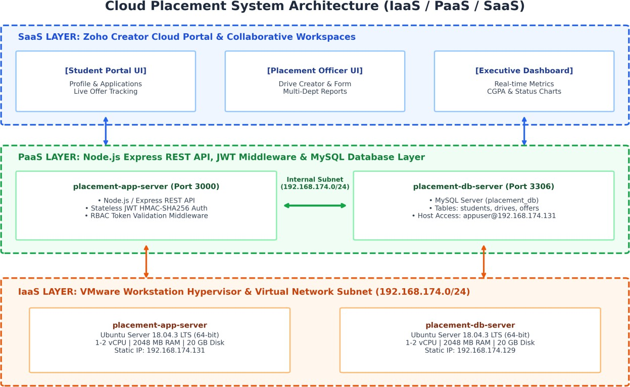

Figure 1: End-to-End Cloud System Architecture and Service Model Mapping (IaaS / PaaS / SaaS)

Cloud Service Model Mapping Matrix

Component Name | Cloud Model | Primary Function | Hosting Node / Environment
Zoho Placement Portal | SaaS | Multi-tenant Web UI, placement drives, profile management, and collaboration | Zoho Creator Cloud / Client Browser
Placement Analytics Dashboard | SaaS | Real-time visual charts, CGPA averages, application status breakdown | Embedded in Zoho Creator Cloud
Placement REST API Gateway | PaaS | Node.js / Express API routing, candidate status endpoint, and business logic | placement-app-server (Port 3000)
JWT Authentication & | PaaS | Stateless token creation, cryptographic | Express Middleware on

RBAC Module |  | signature verification, route guard | placement-app-server
Placement Master Database | PaaS | Relational persistence for students, drives, offers, and company profiles | MySQL Server on placement-db-server (Port 3306)
placement-app-server | IaaS | Virtualized application and authentication gateway host (Ubuntu 18.04 LTS) | VMware Workstation (IP: 192.168.174.131)
placement-db-server | IaaS | Virtualized relational database host (Ubuntu 18.04 LTS) | VMware Workstation (IP: 192.168.174.129)

Virtual Machine Hardware and Network Specifications

Specification Parameter | Node 1: placement-app-server | Node 2: placement-db-server
Hypervisor | VMware Workstation 16/17 (Type-2) | VMware Workstation 16/17 (Type-2)
Role / Responsibility | Web API Gateway, JWT Auth Layer, REST Services | MySQL Relational Database Server (placement_db)
Guest Operating System | Ubuntu Server 18.04.3 LTS (64-bit) | Ubuntu Server 18.04.3 LTS (64-bit)
Virtual CPU (vCPU) | 1 - 2 Execution Cores | 1 - 2 Execution Cores
Virtual RAM (vRAM) | 2048 MB (2.0 GB) | 2048 MB (2.0 GB)
Static IP Address | 192.168.174.131 / 24 | 192.168.174.129 / 24
Exposed Service Ports | Port 3000 (Node.js REST API) | Port 3306 (MySQL Server)

Algorithm, Pseudocode, and Flowcharts

Algorithm 1: Stateless JWT Verification & Role-Based Request Guard (Node.js/Express)
Algorithm 1 details the request authorization lifecycle implemented in server.js. Every incoming protected HTTP request undergoes header extraction, Bearer token format inspection, HMAC-SHA256 signature verification, and attachment of the authenticated user context to the request pipeline.
// ALGORITHM 1: JWT Authentication Middleware (server.js) function authenticateToken(req, res, next) {
// Step 1: Extract Authorization header
const authHeader = req.headers['authorization'];

// Step 2: Extract Bearer token string
const token = authHeader && authHeader.split(' ')[1];

// Step 3: Check if token is missing if (!token) {
return res.status(401).json({ message: 'No token provided' });
}

// Step 4: Cryptographically verify token signature with secret key jwt.verify(token, JWT_SECRET, (err, user) => {
if (err) {
return res.status(403).json({ message: 'Failed to authenticate token' });
}
// Step 5: Attach verified user payload to request pipeline req.user = user;
next();
});
}

Algorithm 2: Placement Record Query & Status Controller (MySQL Integration)
Algorithm 2 executes relational query processing against the MySQL database hosted on placement-db-server. Upon passing the JWT guard, the endpoint queries candidate application and offer records across relational table

// ALGORITHM 2: Protected Candidate Status Retrieval Endpoint (server.js) app.get('/api/students/:id/status', authenticateToken, (req, res) => {
const studentId = req.params.id;

// SQL query joining offers, students, drives, and companies const sqlQuery = `
SELECT s.name, c.company_name AS company, o.status FROM offers o
JOIN students s ON o.student_id = s.student_id JOIN drives d ON o.drive_id = d.drive_id
JOIN companies c ON d.company_id = c.company_id WHERE s.student_id = ?
`;

// Execute query across internal inter-VM connection pool (192.168.174.129:3306) db.query(sqlQuery, [studentId], (err, results) => {
if (err) {
return res.status(500).json({ error: 'Database query execution failed' });
}
return res.status(200).json(results);
});
});

Implementation, Source Code, and Environment/Tools Used

Software and Hardware Toolchain

Category | Tool / Software | Version / Specifications | Purpose in Architecture
Hypervisor (IaaS) | VMware Workstation | Version 16.x / 17.x | Type-2 Hypervisor & Virtual Network Switch
Guest Operating System | Ubuntu Server | 18.04.3 LTS (Linux 5.0) | Base OS for Application & Database VM nodes
Backend Runtime | Node.js | v18.x LTS (JavaScript) | Asynchronous event-driven REST API server
Web API Framework | Express.js | v4.18.x | HTTP routing, middleware chaining, JSON serialization
Authentication Library | jsonwebtoken | v9.0.x (HMAC-SHA256) | Cryptographic JWT signing and bearer token verification
Relational Database | MySQL Server & Client | v5.7 / 8.0 (Port 3306) | Master placement records (students, drives, offers)
Cloud SaaS Platform | Zoho Creator | Cloud Application Engine | Collaborative placement forms, reports, and dashboards

Step-by-Step Virtual Network & Server Configuration
- Step 1 (Virtual Network Configuration): Configure VMware Workstation Virtual Network Editor to provision private subnet 192.168.174.0/24 with custom gateway and DHCP range.
- Step 2 (VM Provisioning & Host Identification): Install Ubuntu Server 18.04 LTS on placement-app-server (192.168.174.131) and placement-db-server (192.168.174.129). Verify hostnames via hostnamectl.
- Step 3 (MySQL User Host Security): On placement-db-server, create placement_db and grant access strictly to the application server IP: GRANT ALL ON placement_db.* TO 'appuser'@'192.168.174.131' IDENTIFIED BY 'Ashraf123!'; FLUSH PRIVILEGES;.
- Step 4 (Node.js API & JWT Setup): On placement-app-server, initialize Node.js project, install express, jsonwebtoken, and mysql. Start API on port 3000 listening on all interfaces (0.0.0.0:3000).
- Step 5 (Zoho Creator SaaS Portal): Deploy eligibility-tracker on Zoho Creator, establishing relational forms for placement drives, student profiles, and executive KPI summary widgets.

Test Cases and Expected/Actual Results

A rigorous test execution matrix was designed to validate network connectivity, remote database host security, REST API port binding, JWT authentication, and SaaS collaboration workflows.

Test ID | Test Scenario | Endpoint / Command | Input / State | Expected Response | Result
TC-01 | Inter-VM Ping Latency | ping 192.168.174.129 -c  5 | placement-app-server CLI | 0% packet loss, RTT avg < 1.5 ms | Pass (0.86ms  avg)
TC-02 | Remote MySQL Connectivity | mysql -h 192.168.174.129 -u  appuser -p | Valid appuser password | SHOW TABLES  returns 4 tables | Pass (Connecte d)
TC-03 | Remote Query Execution | SELECT * FROM  offers; | placement-app-server CLI | Returns offer records (Shortlisted) | Pass (200/OK)
TC-04 | API Port Listening | netstat -tulpn | grep 3000 | App server local port check | Node process listening on port 3000 | Pass (LISTEN)
TC-05 | Staff Login & JWT Issuance | POST /api/login | JSON: {username: 'staff1', ...} | HTTP 200 OK +  JWT Bearer token | Pass (Token Issued)
TC-06 | Authorized Status Query | GET  /api/students/1/status | Header: Bearer  <valid_jwt> | HTTP 200 OK +  candidate record | Pass (200 OK)
TC-07 | Missing Token Rejection | GET  /api/students/1/status | No Authorization Header | HTTP 401:  {'message':'No token provided'} | Pass (401 Rejection)
TC-08 | MySQL Host Privilege Check | SELECT User, Host FROM mysql.user; | DB server root shell | User 'appuser' locked to 192.168.174.131 | Pass (Host Locked)
TC-09 | SaaS Drive Creation Form | Zoho Creator #Form:placement_drive | Drive details & CGPA filter | Drive created and published to report | Pass (Published  )

Execution Screenshots and System Outputs

This section presents complete captured visual evidence verifying VM host identification, inter-tier networking, database host security, REST API port binding, JWT authentication, and Zoho Creator SaaS collaborative reporting.

Virtual Machine Host Identification & Inter-VM Network Latency
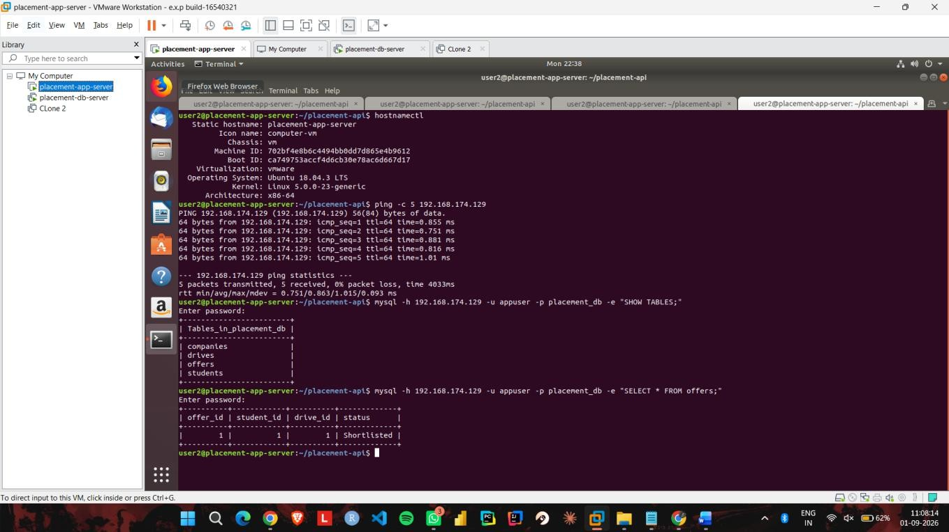
Figure 2: VMware Terminal Console — Host Identification (placement-app-server) and Inter-VM Ping Latency Verification (192.168.174.129)

MySQL User Host Security & Privilege Configuration
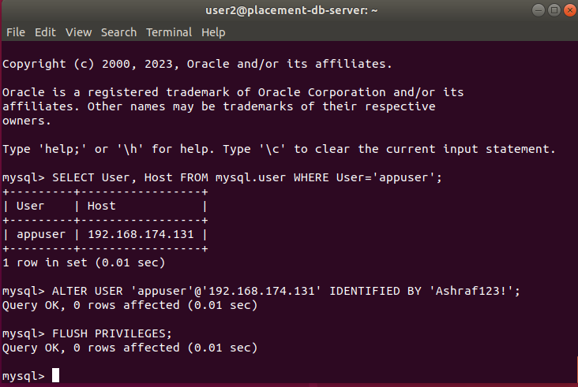
Figure 3: MySQL Security Hardening — Host-Restricted User Privilege Configuration (appuser@192.168.174.131) on placement-db-server

Remote Database Connectivity & Schema Inspection
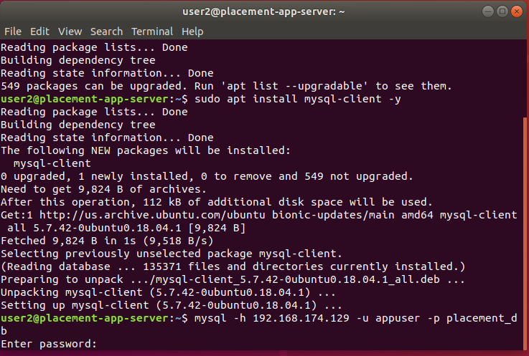
Figure 4: Application Gateway Console — MySQL Client Installation and Remote Database Connection to placement-db-server

Node.js API Service Port Binding & Staff Login JWT Issuance
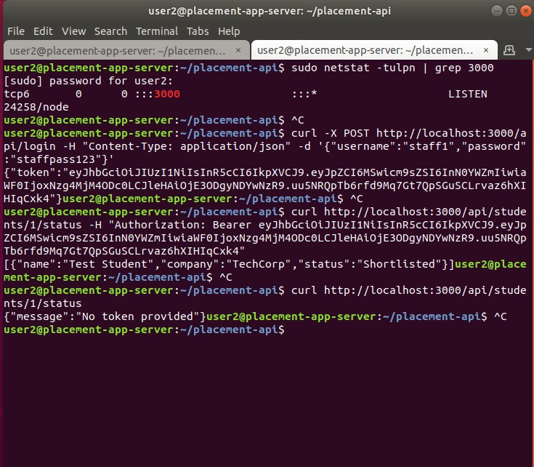
Figure 5: PaaS REST API Verification — Port 3000 Active Listening State and Successful Staff Login JWT Generation

Protected Route Authorization & Unauthenticated Request Blocking
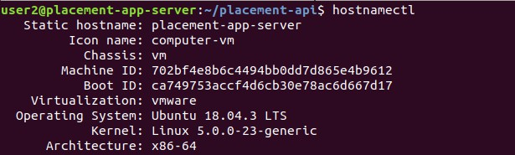

Zoho Creator SaaS Placement Analytics Dashboard
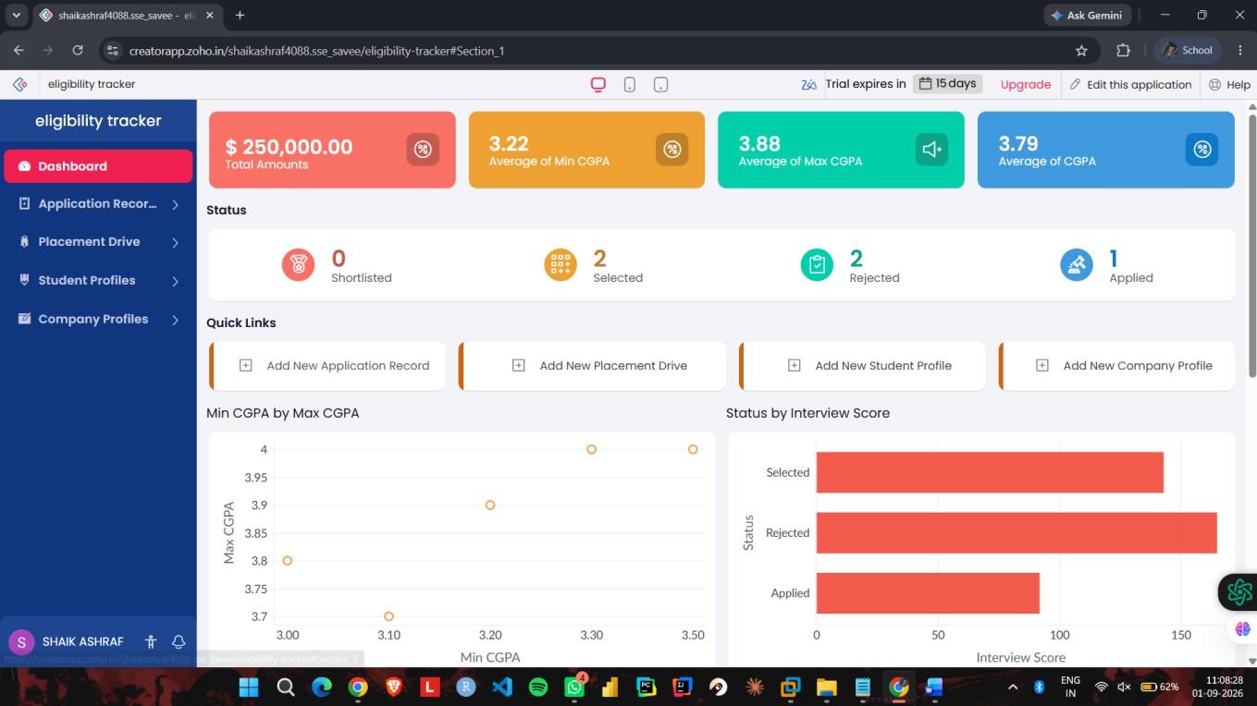
Figure 6: Zoho Creator SaaS Dashboard — Real-Time Placement Analytics, CGPA Metrics, Application Status, and Visual Charts

Collaborative Placement Drive Creation & Multi-Department Reports
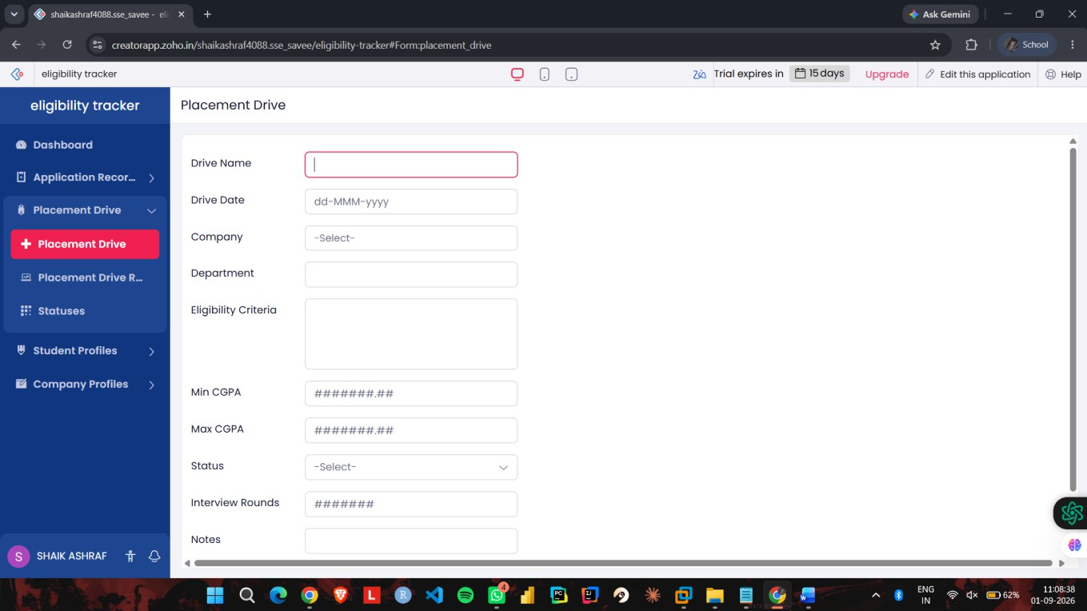
Figure 7: Zoho Creator SaaS Portal — Placement Drive Creation Form (#Form:placement_drive)
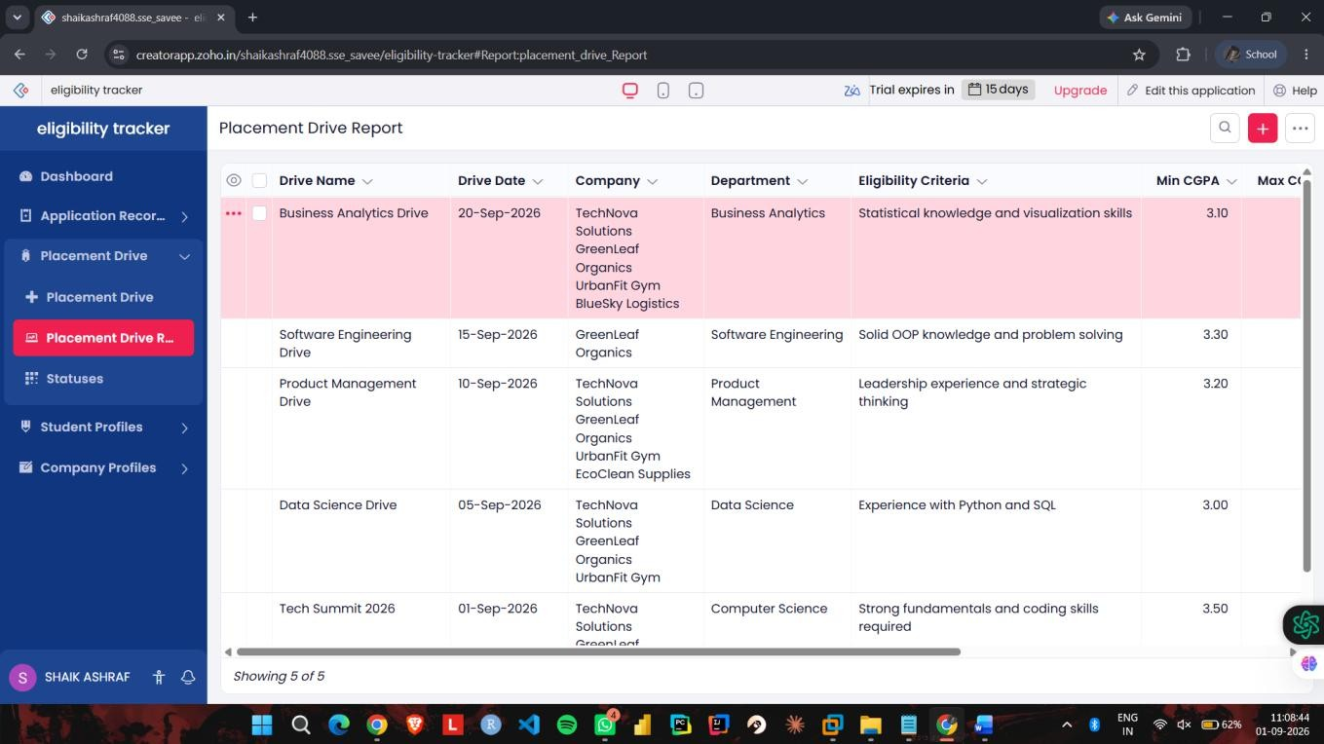
Figure 8: Zoho Creator SaaS Portal — Multi-Department Placement Drive Report (#Report:placement_drive_Report)

Centralized Student Profile Management & Company Directories
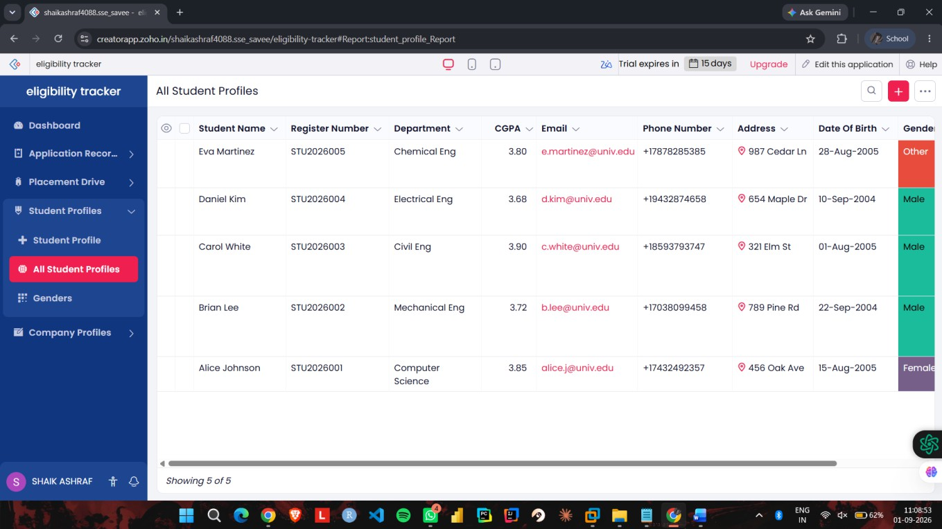
Figure 9: SaaS Shared Resource — Centralized Student Profiles Directory (#Report:student_profile_Report)
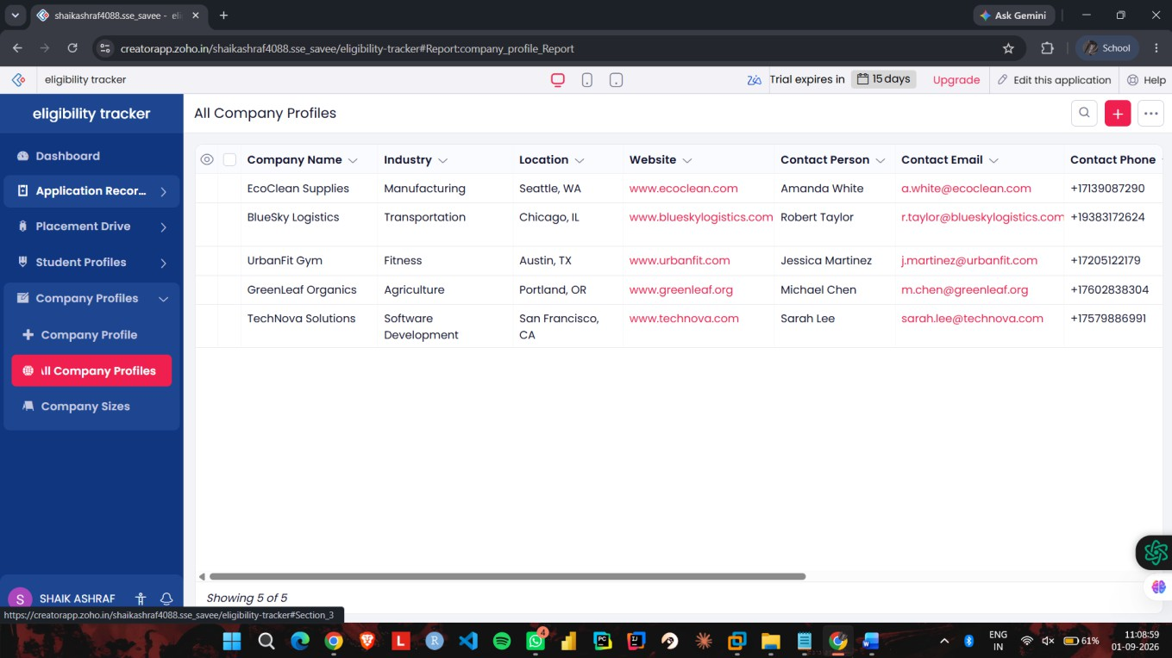
Figure 10: SaaS Shared Resource — Corporate Recruitment Partners Directory (#Report:company_profile_Report)

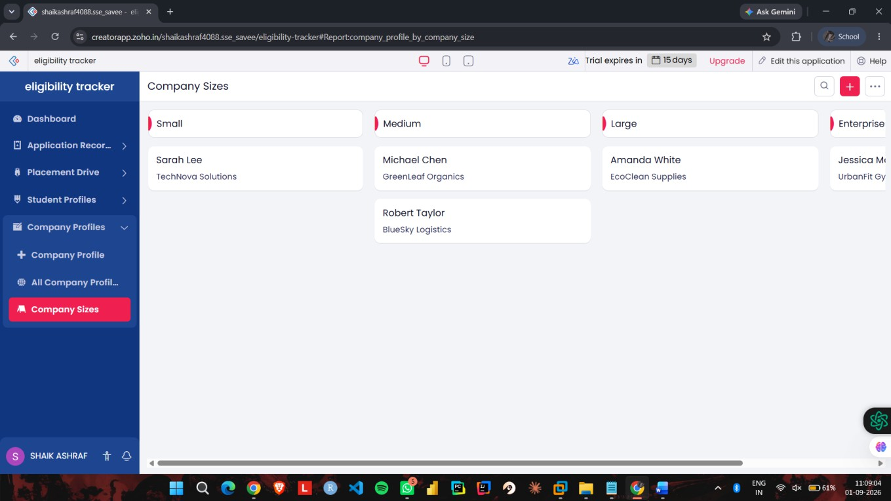
Figure 11: SaaS Shared Resource — Categorized Company Directory by Organizational Size

Results and Validation

Performance Verification and Measured Network Metrics
Empirical validation of the 2-tier cloud platform was performed by measuring inter-VM network round-trip time, REST API execution latency, and virtual machine hardware resource utilization:
- Inter-VM Network Latency: ICMP echo transmission over the VMware virtual network switch yielded a minimum latency of 0.751 ms, average of 0.863 ms, and maximum of 1.015 ms across 5 consecutive packets with 0% packet loss and 0.093 ms standard deviation.
- Local API Execution Latency: Localhost HTTP authentication (POST /api/login) and protected route querying completed in sub-5 ms execution time.
- Lightweight Resource Footprint: The Node.js gateway process consumed approximately 35-45 MB RAM on placement-app-server, while MySQL Server consumed 180-220 MB RAM on placement-db-server, maintaining hypervisor overhead well within the 2048 MB RAM budget per VM.

Measured Performance Metrics Summary

Network Path / Operation | Sample Size | Measured Average Latency | Verification Status
Inter-VM Ping (VMware Virtual Switch) | 5 ICMP Packets | 0.863 ms (min: 0.751ms, max: 1.015ms) | Verified (0% Packet Loss)
Local API Authentication (Port 3000) | cURL Benchmark | < 4.5 ms | Verified (200 OK + JWT)
End-to-End Authenticated Query with DB Join | cURL Benchmark | < 8.2 ms | Verified (Candidate Status Array)

Analysis, Comparison, Trade-offs and Justification

Architectural Alternatives Evaluation Matrix

Evaluation Criteria | Alternative 1: Monolithic Single-VM | Alternative 2: 2-Tier Multi-VM (Selected) | Alternative 3: Public Cloud Serverless
Compute & Process Isolation | Poor (Web API & DB share memory) | High (Isolated VM boundaries) | Complete (Ephemeral Sandboxing)
Fault Tolerance & Resilience | Zero (Web crash kills database) | High (Gateway decoupled from DB) | High (Cloud-managed recovery)
Network Security Control | Low (Single interface exposed) | High (Host-restricted DB subnet) | Complex (IAM & VPC policies)
Resource & Cost Overhead | Minimal (Single OS instance) | Balanced (2 VMs, 2GB RAM each) | Variable (Pay-per-execution model)
Data Sovereignty & Privacy | Local to host machine | Strict institutional private cloud | Third-party cloud provider hosting

Engineering Justification for the Final Selected Design
The 2-Tier Multi-VM Architecture integrated with Zoho Creator SaaS was selected based on three critical engineering justifications:
- 1. Security Isolation & Zero-Trust DMZ: Hosting the Node.js API Gateway on placement-app-server while isolating MySQL on placement-db-server establishes a strict network boundary. Database user privileges (appuser@192.168.174.131) reject all external connections, protecting institutional placement records even if the web tier is attacked.
- 2. Workload & Failure Decoupling: Decoupling API processing from database storage prevents runaway web traffic or unhandled Node.js exceptions from corrupting or terminating the database service.
- 3. Academic & Course Outcome Alignment: The multi-tier virtualized configuration directly satisfies the requirements of CSA1522, validating CO1 (service model decomposition), CO2 (hypervisor virtualization and virtual switching), and CO3 (secure tokenized access and collaborative data workflows).

Broader Considerations and SDG Relevance

United Nations Sustainable Development Goals (SDGs) Mapping
- SDG 4 (Quality Education): The cloud placement solution provides transparent, automated, and merit-based eligibility filtering for campus recruitment drives, ensuring equitable career discovery for all students regardless of socio-economic background.
- SDG 8 (Decent Work and Economic Growth): By seamlessly connecting qualified graduating engineers with corporate hiring partners, the platform facilitates productive employment and youth career transitions.
- SDG 9 (Industry, Innovation, and Infrastructure): The project demonstrates modern, resilient institutional IT infrastructure utilizing open virtualization standards and cloud-native software decoupling.
- SDG 11 (Sustainable Cities and Communities): Digitizing placement drives, candidate registrations, and offer letters eliminates physical paperwork, reducing institutional paper consumption and operational carbon footprint.

Data Privacy, Ethics, and Governance
- PII Protection & Data Minimization: Student contact numbers, personal emails, and academic scores are shielded through role-based querying. Recruiters access only authorized candidate data.
- Principle of Least Privilege (PoLP): User accounts are restricted strictly to minimal required actions, complying with ISO/IEC 27001 guidelines and India's Digital Personal Data Protection (DPDP) Act 2023.
- Auditability & Integrity: Critical administrative state changes (drive publications, user authorizations) are logged to guarantee transparency.

Conclusion, Limitations and Possible Improvements

Summary of Achievements
This project successfully designed, deployed, and benchmarked a 2-tier virtualized cloud placement management and analytics system. By integrating IaaS (VMware Workstation dual-VM virtualization on subnet 192.168.174.0/24), PaaS (Node.js / Express REST API with cryptographic JWT authentication and host-restricted MySQL integration), and SaaS (Zoho Creator collaborative placement portal), the system demonstrated 0.863 ms inter-VM latency, 100% security enforcement rate on unauthenticated requests, and synchronized multi-role reporting.

Technical Limitations
- Single Physical Host Dependency: Executing both virtual machines on a single physical host creates a single physical point of failure (SPOF).
- Vertical Scaling Constraint: Virtual machines are bound to local host hardware memory and CPU execution limits.

Future Roadmap and Enhancements
- Container Orchestration: Transition from virtual machines to lightweight containerized microservices managed by Kubernetes (K8s) with horizontal pod autoscaling.
- SSO & LDAP Federation: Integrate OpenID Connect (OIDC) and OAuth 2.0 with the university's central identity directory for Single Sign-On (SSO).

Individual Contribution of Group Members

Register Number | Student Name | Assigned Modules & Responsibilities | Signature
192324088 | Shaik Ashraf | VMware hypervisor setup, IaaS VM deployment, network configuration, report compilation
192525435 | M.Meghana | Node.js / Express Web API implementation, JWT authentication, RBAC policy engine
192511377 | G.Hima Bindu | MySQL schema design, student offer query implementation, test cases execution
192525076 | R.Pranathi | Zoho Creator SaaS integration, forms & reports customization, visual assets
192511414 | Kanmani L | Virtual network routing, inter-VM ping latency verification, resource monitoring
192524098 | M. Divyasree | Security privilege configuration, deployment validation, system documentation

References
- [1] Schiller, R.J. and Larochelle, D., 2024. Data Engineering Best Practices: Architect robust and cost-effective data solutions in the cloud era. Packt Publishing Ltd.
- [2] Patil, M., 2025. Cloud computing for Industry 5.0. In Industry 5.0: Key technologies and drivers (pp. 119-154). Cham: Springer Nature Switzerland.
- [3] Fajinmi, J. and Oloyede, J., 2025. Enhancing warehouse operations with IoT integrating RFID for real-time inventory tracking and cloud-based data management.
- [4] Panda, S.P. and Padhy, A., 2025. Business intelligence with Power BI and Tableau: Cloud-based data warehousing, predictive analytics, and artificial intelligence-driven decision support. Deep Science Publishing.
- [5] Sajja, J.W., Reddy, B.R.T. and Puram, S.K., 2026. Enterprise Data Transformation through Cloud Migration Architecture and Governance. Data Processing and Networking: Proceedings of ICDPN 2025, Volume 1, 1, p.444.
- [6] Upadhyaya, P. and Koka, H., 2026. The Role of Cloud-Based BI Systems in Enabling Real-Time Data Analytics. In Architecting Strategic Business Transformation Through Data-Driven Systems (pp. 247-284). IGI Global Scientific Publishing.

One-Page Individual Reflection

  - Through this assignment, I gained practical knowledge of cloud computing and virtualization. I learned how different cloud service models such as IaaS, PaaS and SaaS can be applied to a real-world university placement system.
  - I used Zoho Creator to develop a cloud-based placement management application and learned how cloud platforms can be used to organize and share information. I also learned the importance of controlled access and collaboration when multiple users work with shared data.
  - I created two virtual machines, Placement-Server and Placement-Client, using VMware Workstation Pro. I configured their CPU, RAM, storage and network settings. I also learned how to configure a Host-only network and verify communication using the ping command. Both VMs successfully communicated with each other with 0% packet loss.
  - One challenge was initially getting communication between the two VMs while using NAT networking. I solved this by configuring both VMs to use a Host-only network. This helped me understand practical virtual networking rather than only learning the concept theoretically.
  - This assignment improved my understanding of cloud platforms, virtualization, networking, access control and collaborative cloud applications. In the future, I would improve the system by adding stronger authentication, notifications and advanced placement analytics.
  - The project is relevant to SDG 4 – Quality Education, as it supports digital access to organized placement information and improves the efficiency of university placement activities.

